**PROJECT REPORT**

**AI CAR PARKING USING OPEN CV**

*Submitted By*

**R.VISHALI(953520104002)**

**V.SUBHASHINI(953520104001)**

**M.JOTHILAKSHMI (953520205001)**

**M.KAVIYA (953520205002)**

*In partial fulfilment for the award of the degree of*

**BACHELOR OF ENGINEERING/TECHNOLOGY**

*In*

**COMPUTER SCIENCE ENGINEERING**

**/**

**INFORMATION TECHNOLOGY**

**VPMM ENGINEERING COLLEGE FOR WOMEN**

**KRISHNANKOVIL – 626190.**

*(Approved by AICTE, New Delhi and Affiliated to Anna University, Chennai)*

**ANNA UNIVERSITY::CHENNAI 600 025**

**MAY 2023**

**TABLE OF CONTENTS**

1 INTRODUCTION

1.1 Project overview

1.2 Purpose

2 LITERATURE SURVEY

2.1 Exisiting problem

2.2 References

2.3 Problem statement definition

3 IDEATION AND PROPOSED SOLUTION

3.1 Empathy Map Canvas

3.2 Ideation and Brainstorming

3.3 Proposed solution

3.4 Problem Solution Fit

4 REQUIREMENT ANALYSIS

4.1 Functional requirements

4.2 Non-Functional requirements

5 PROJECT DESIGN

5.1 Data Flow Diagrams

5.2 User Stories

5.3 Solution and technical architecture

6 PROJECT PLANNING AND SCHEDULING

6.1 Sprint Planning and Estimation

6.2 Sprint Deliver Schedule

7 CODING AND SOLUTIONING(Explain the features added in the project along with code)

7.1 Feature 1

7.2 Feature 2

8 ADVANTAGES AND DISADVANTAGES

9 CONCLUSION

10 FUTURE SCOPE

GITHUB

PROJECTDEMO

**1.INTRODUCTION**

**1.1 PROJECT OVERVIEW**

This automated system is used to find the vacancy in parking spaces available and navigate the driver to reach the desired space using visuals and in an effective manner, thus reducing search time. This system is required for malls, multistorey parking structures, IT hubs and parking facilities. This makes sure the requirement of labour is insubstantial.

**1.2 PURPOSE**

This project deals with an effective way of finding empty spaces and managing the number of vehicles moving in and out in complex multi storeyed parking structures by detecting a vehicle using IR sensors and thus providing a feedback. The fully automated smart car parking system is rudimental and does not require heavy lines of code nor expensive equipment. It is a simple circuit built for the exact need of purpose.

**2.LITERATURE SURVEY**

**2.1 EXISTING PROBLEM**

Car parking is a major problem in urban areas in both developed and developing countries. Following the rapid incense of car ownership, many cities are suffering from lacking of car parking areas with imbalance between parking supply and demand which can be considered the initial reason for metropolis parking problems. This imbalance is partially due to ineffective land use planning and miscalculations of space requirements during first stages of planning. Shortage of parking space, high parking tariffs, and traffic congestion due to visitors in search for a parking place are only a few examples of everyday parking problems.

**2.2 REFERENCES**

Bagula, Antoine, Lorenzo Castelli, and Marco Zennaro. On The

Design of Smart Parking Networks in the Smart Cities: An

Optimal Sensor Placement Model. Open Access Sensors 15

(2015): 15443-15467. Print.

**2.3 PROBLEM STATEMENT DEFINITION**

This imbalance is partially due to ineffective land use planning and miscalculations of space requirements during first stages of planning. Shortage of parking space, high parking tariffs, and traffic congestion due to visitors in search for a parking place are only a few examples of everyday parking problems.

**3.IDEATION AND PROPOSED SOLUTION**

**3.1 EMPATHY MAP CANVAS**



**3.2 IDEATION AND BRAINSTORMING**

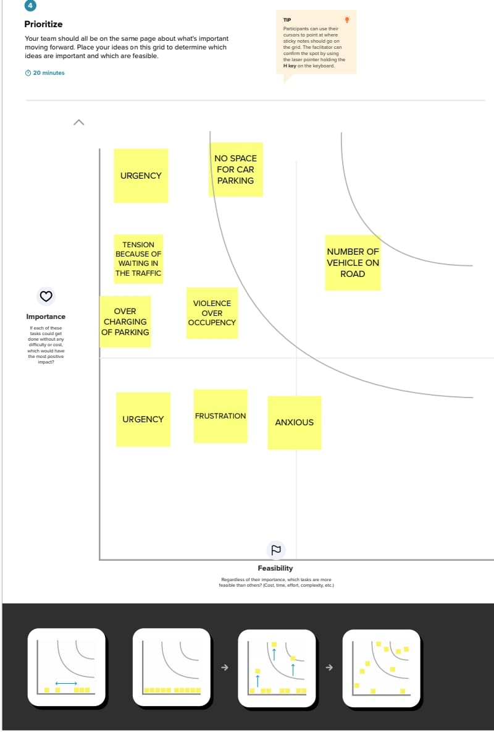

**3.3 PROPOSED SOLUTION**

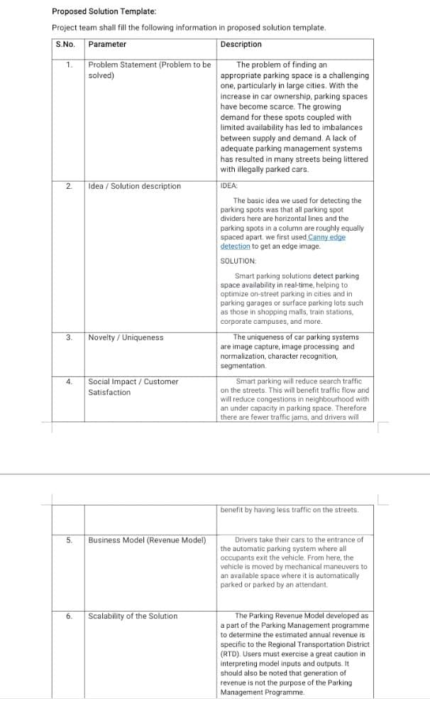

**4.REQUIREMENT ANALYSIS**

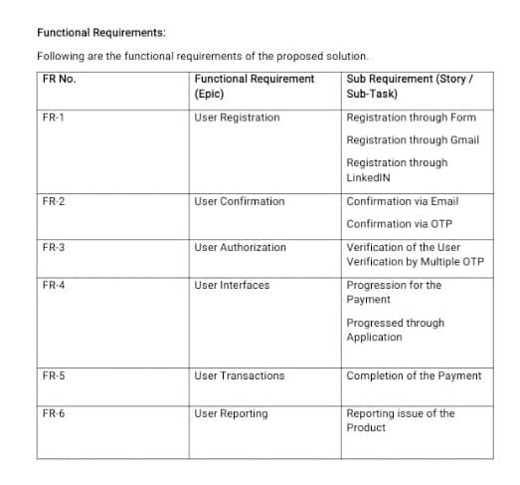



**5.PROJECT DESIGN**

**5.1 DATA FLOW DIAGRAM**

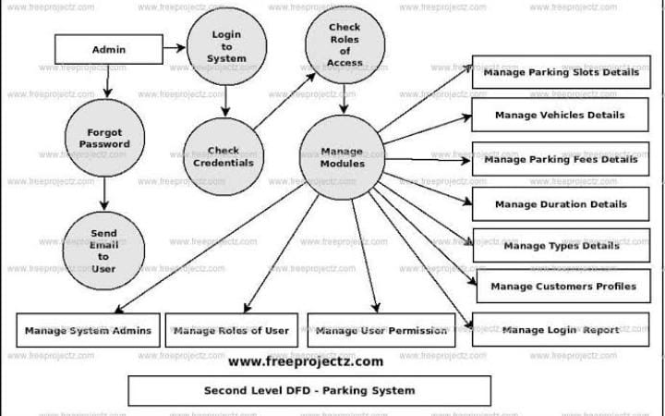

**5.2 USER STORIES**

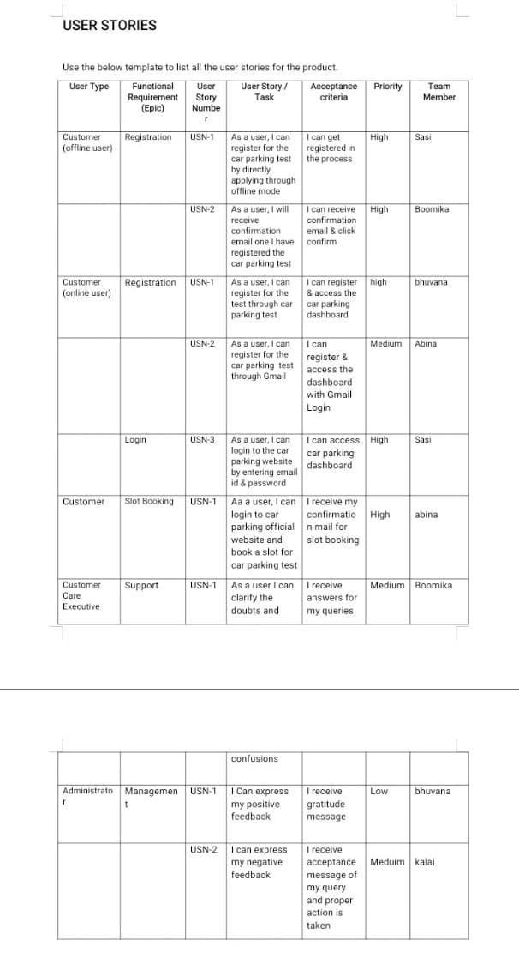

**5.3 SOLUTION ARCHITECTURE**

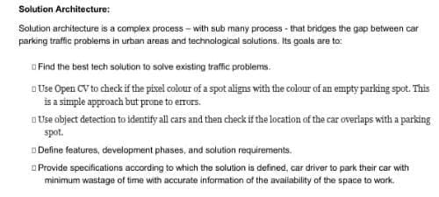

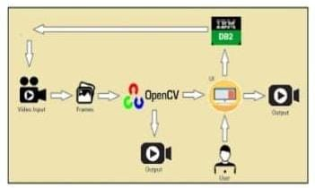

**6.RESULT OF THE EXPERIMENT**

The smart car parking system is built for real-life applications.Thus, quality and consistency are mandatory. Thus, we carriedout some testing experiments using the prototype system to

evaluate its dependability. The test area consisted of twoparking areas of ten lots each divided into section A and B.However; equipment were only installed in parking lot A1

where the physical testing was carried. It was not possible totest the result physically for both lots: A1 & B1, hence for thisproject we took the help of the simulation tool (XCTU) todemonstrate the occupancy of the car park A1 and B1.

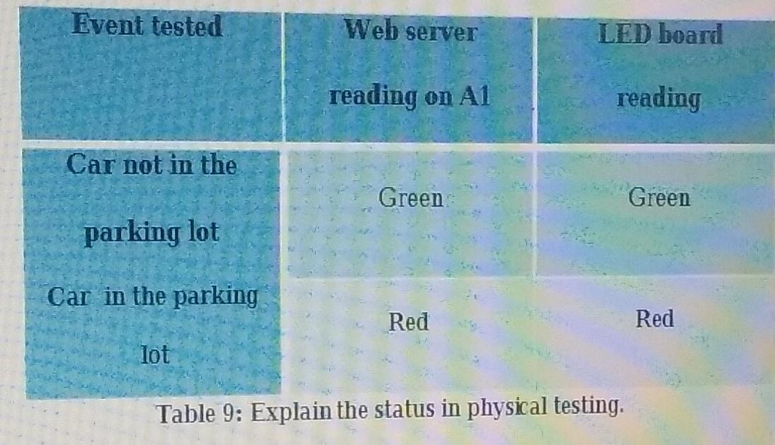

**7.CODING AND SOLUTIONING**

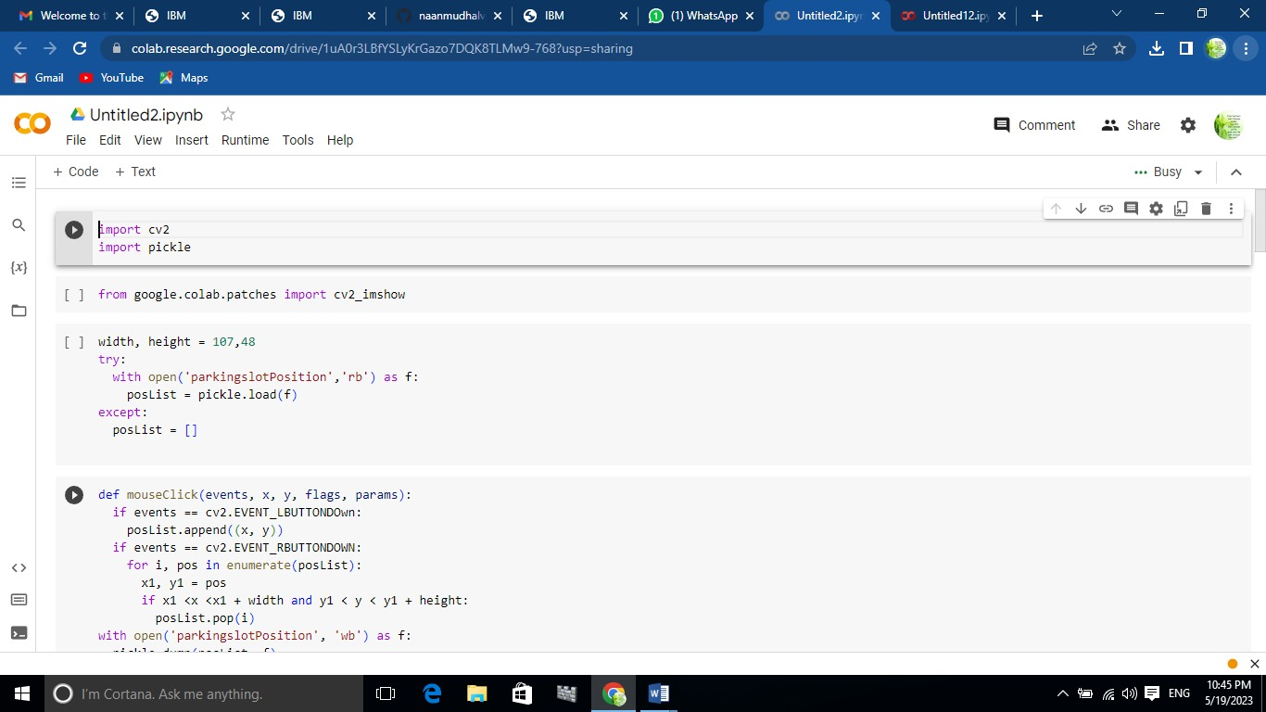

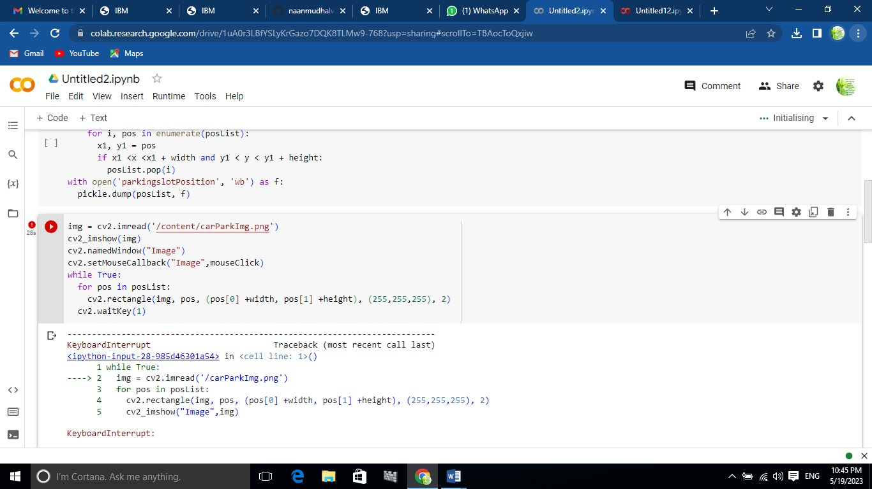

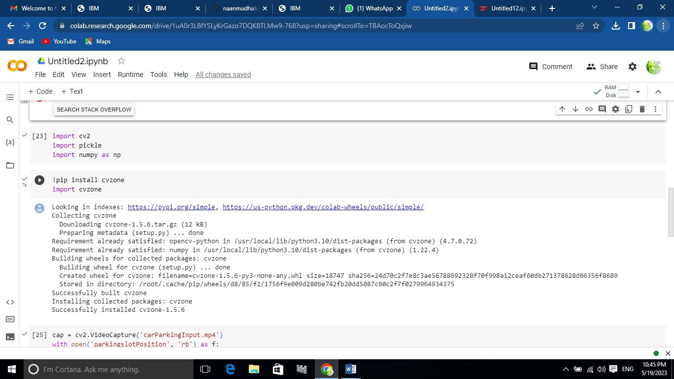

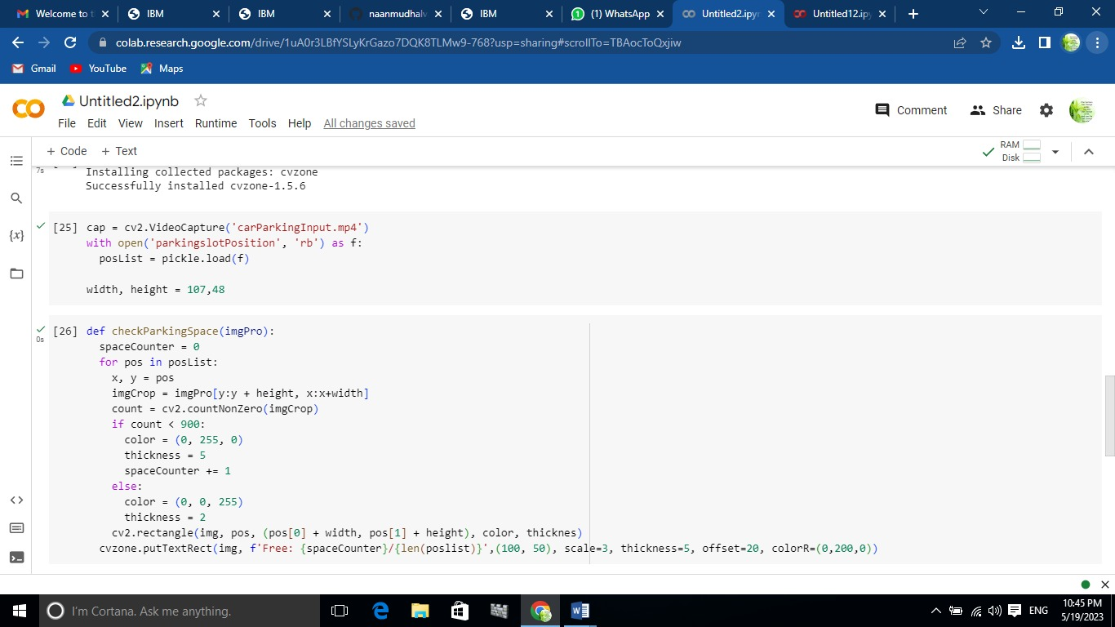

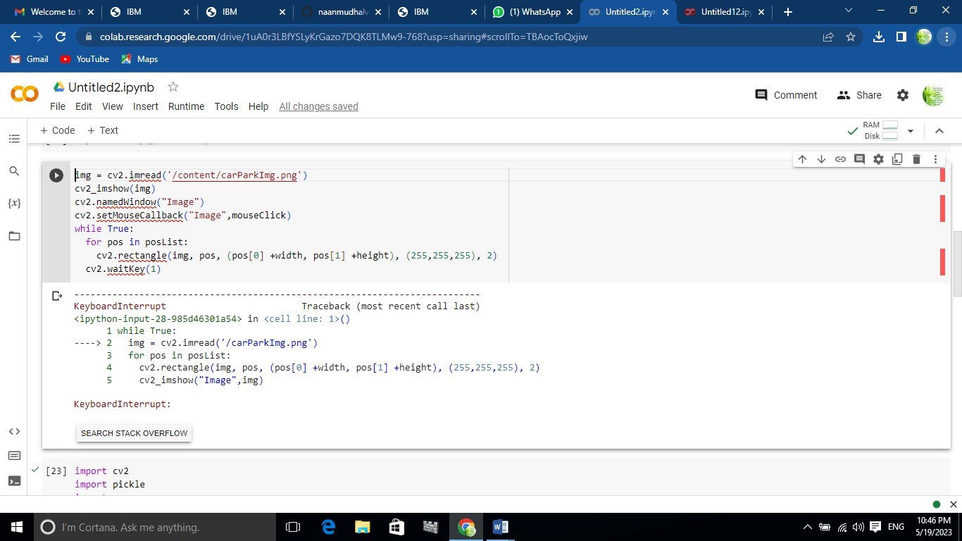

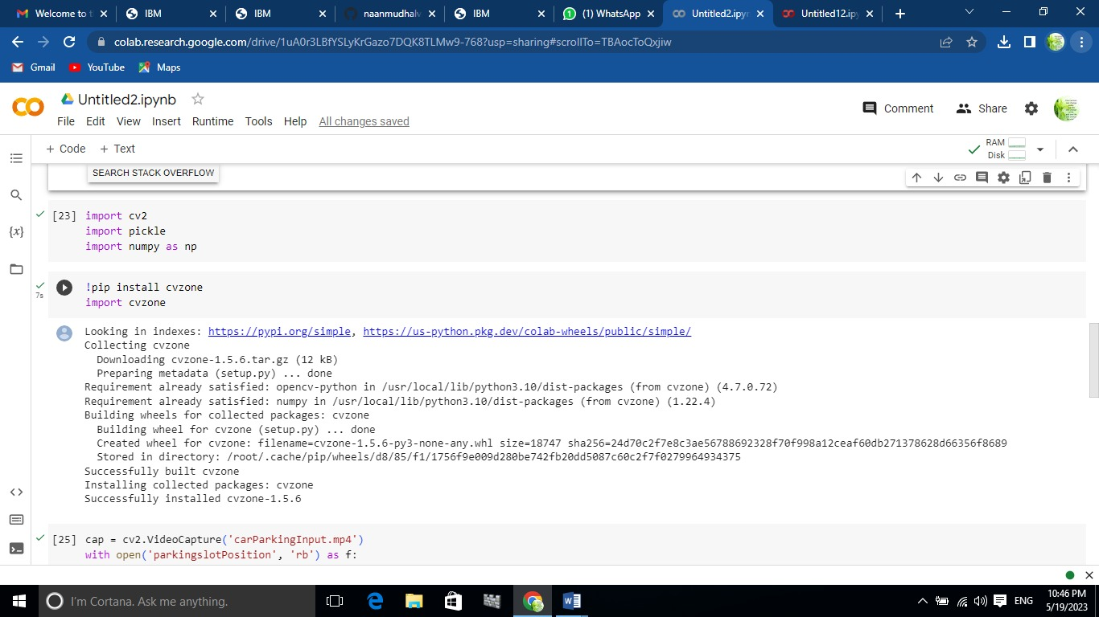

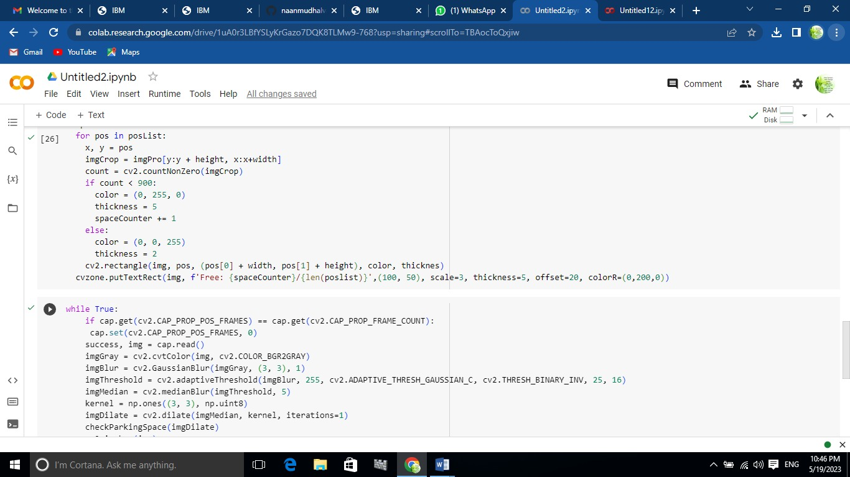

**8.ADVANTAGES AND DISADVANTAGES**

**ADVANTAGES**

* Improved parking efficiency
* Enhanced user experience
* Optimal space utilization
* Cost savings
* Increased safety and security
* Real-time monitoring and reporting

**DISADVANTAGES**

* Dependency on camera installation
* Limited accessibility for non-camera equpied vechicles

**9.CONCLUSION**

The AI enabled car parking system holds significant potential in addressing the parking challenges face in urban areas. With further development and integration into existing parking management systems. It can contribute to creating smarter and more efficient cities.

**10.FUTURE SCOPE**

* Scalability and integration
* Advanced parking analytic
* Mobile application and real-time updates

**GITHUB**

[**https://github.com/Vishalirv31/Vishalirv31.git**](https://github.com/Vishalirv31/Vishalirv31.git)

**PROJECT DEMO**

[**https://drive.google.com/file/d/1eJbOhwHBb9jVGljnS6b94DWToTM2w2uv/view?usp=sharing**](https://drive.google.com/file/d/1eJbOhwHBb9jVGljnS6b94DWToTM2w2uv/view?usp=sharing)